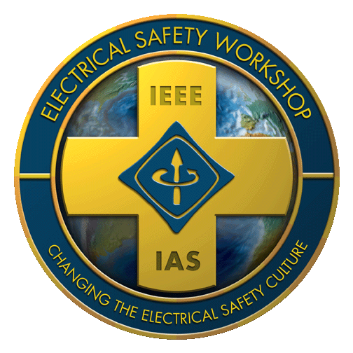

Prevention through Design Student Engineering Education Initiative
Application Form
Thank you for your interest in applying to the IAS Electrical Safety Prevention through Design Student Engineering Education Initiative! Please complete this application form and return by email by November 15 to the Program Coordinator (noted at the bottom of this form) in ONE pdf document. You may work in collaboration with your graduate advisor.
In your application, please include:
- Two letters of recommendation from current or past graduate professors.

-and-

- Electrical Safety Course Option: An abstract (less than 200 words) addressing: “How I would design a college course about electrical safety.” Include: why electrical safety should be component of any university’s engineering program; a brief description of the projects or assignments you would include as part of this course. After your abstract, not to be included in your word count, cite at least three peer reviewed papers that support your perspective.

-or-

- Research Option: An abstract (less than 200 words) addressing: How your own research makes an important contribution to the field of electrical safety.

Applicant Information
Last Name: ___________________________ First Name: __________________________ Sex: € Male € Female
University: _________________________________________________________________________________
University Address: __________________________________________________________________________
University Country: __________________________________________________________________________
Department: _____________________________ Advisor: ___________________________________________
Email address: ____________________________________________________________________
Degree to be obtained: € M.S. € Ph.D. Expected graduation year: ____________________

Develop the abstract that you submitted for your application into a poster presentation.

- Electrical Safety Course Option: Tell us, in a poster presentation format, about how you would design a college level course about electrical safety. Include: why electrical safety is an important component of engineering programs, include a description of the topics you would include, a description of the projects or assignments you would include, and a reading list of about 10 journal articles, book chapters, and textbooks that you would include.

- Research Option: Tell us, in a poster presentation format, about your own research. Include an introduction that explains how your research contributes to the field of electrical safety. Next, describe your hypotheses, methods, and results.

- Templates to use for both poster options may be viewed online at the IEEE IAS ESW Student page.

The Electrical Safety Workshop runs from a Tuesday through a Friday, with Tutorials offered the preceding Monday. Which days will you attend the ESW, should you be selected as a recipient? Please consider that preference will be given to students who are able to attend the entirety of the workshop.
€ Monday € Tuesday € Wednesday € Thursday € Friday

If your application is selected, you will be asked to present the proposed research through a poster presentation at the ESW. Following to ESW presentation, the students will be invited to write and submit a full manuscript, specifically based on the presented research with the same title and on the same topic, for possible publication at IEEE Transactions on Industry Applications or IEEE Industry Applications Magazine. The lead author should be a student followed by the academic advisor and collaborators, but the authors list and the order should remain unchanged through the process. The submitted papers will be rigorously reviewed by the technical committee, similar to any other technical publication in IEEE Industry Applications Society, and a decision will be made and communicated to the authors.

For further information about the IAS Electrical Safety Prevention through Design Student Engineering Education Initiative program, please click on “For Students” on our website at https://electricalsafetyworkshop.com/students/

Submit the application package to:

Prof. Payman Dehghanian
Student Program Chair, IEEE IAS Electric Safety Workshop (ESW) 2022.
Email: payman.dehghanian@ieee.org or payman@gwu.edu

